Wrds studio code_delta and vega

1) Code Source: http://kaichen.work/?p=211

2) Definition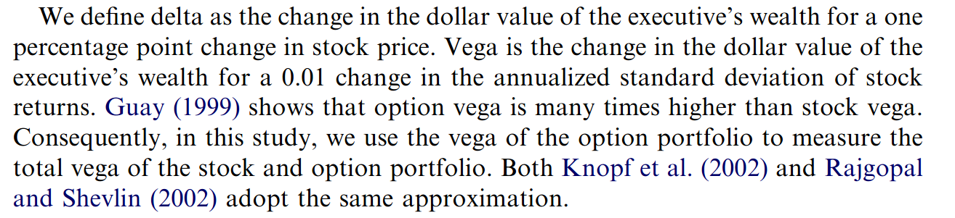

Reference:

Coles, Jeffrey L., Naveen D. Daniel, and Lalitha Naveen. "Managerial incentives and risk-taking." *Journal of financial Economics* 79.2 (2006): 431-468.